**Create a simple cloud software application for online super market using any Cloud Service Provider to demonstrate SaaS with the template of customer name, address, phone, email, items, quantity etc. with the item classification form**

**AIM:**

Create a simple cloud software application for Property Buying & Rental process (In Chennai city) using any Cloud Service Provider

**PROCEDURE:**

**STEP 1:**

Open browser and get into zoho ceator. Then sign in and click “Create application”. Below given screenshot will appear, hear type the application name of your Aim.

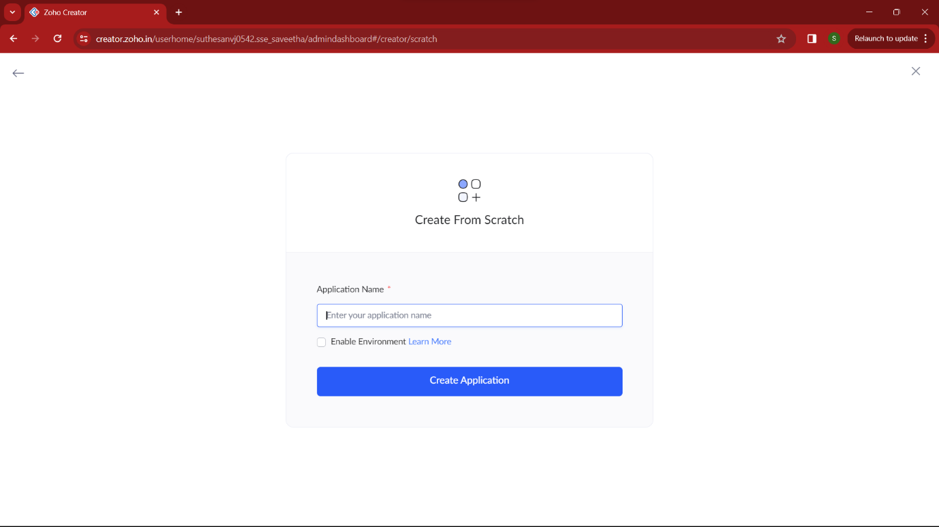

**STEP 2:**

Then select “start from scratch” option and select the proper component from the 4 components listed. For my application I just selected “forms” for the login credentials.

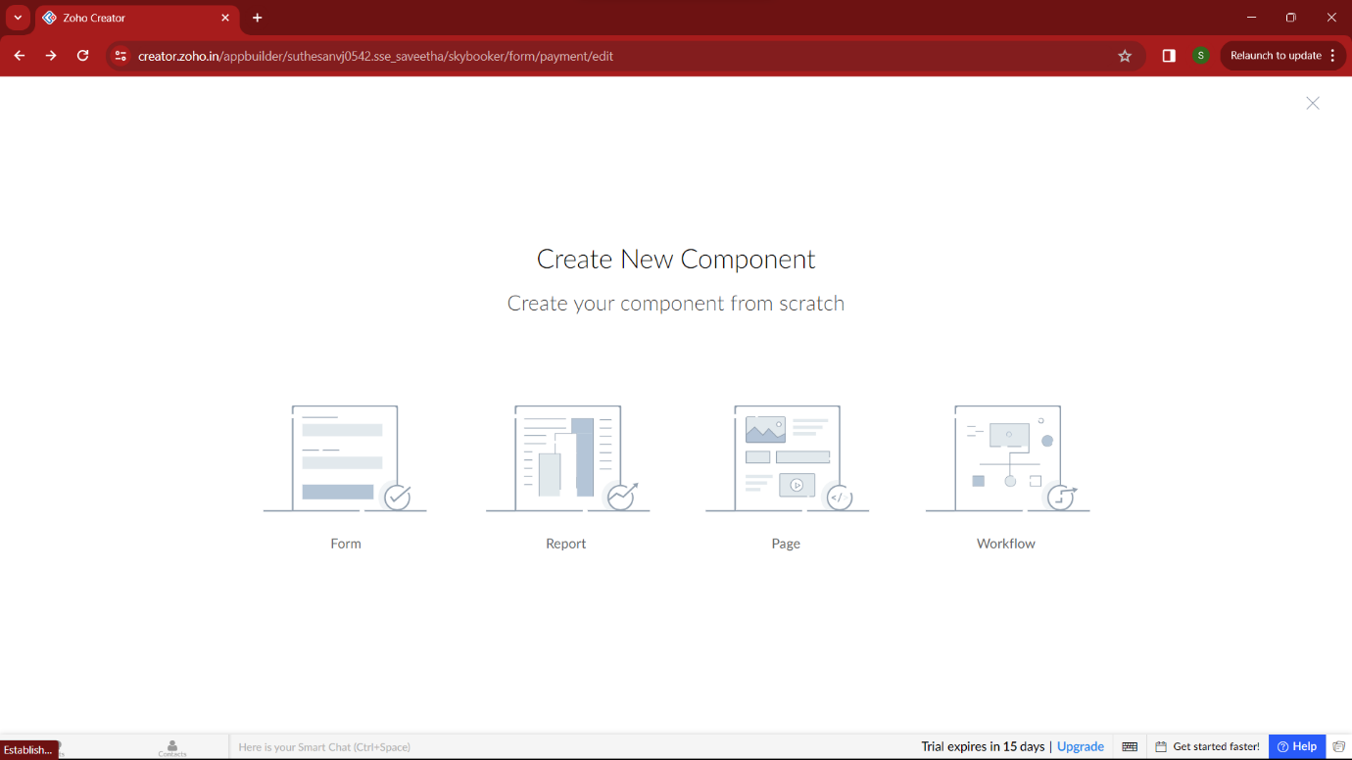

**STEP 3:**

In forms, below given options will be given. From here we can get sample templates of our requirements, otherwise we can import already saved schema for our application. I just selected “ from scratch” option for my application.

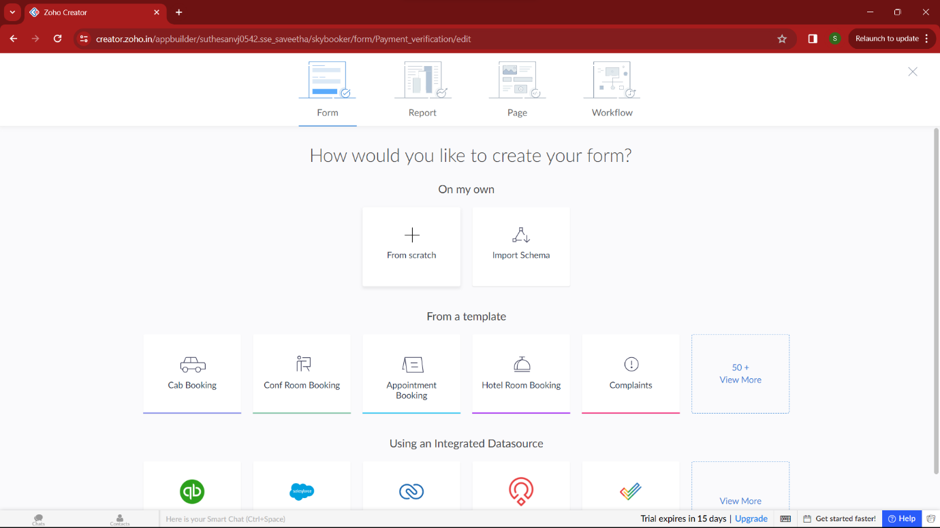

**STEP 4:**

Then provide an appropriate name for our application in the name form which shown below. I gave “AddCart” for my “Online supermarket”

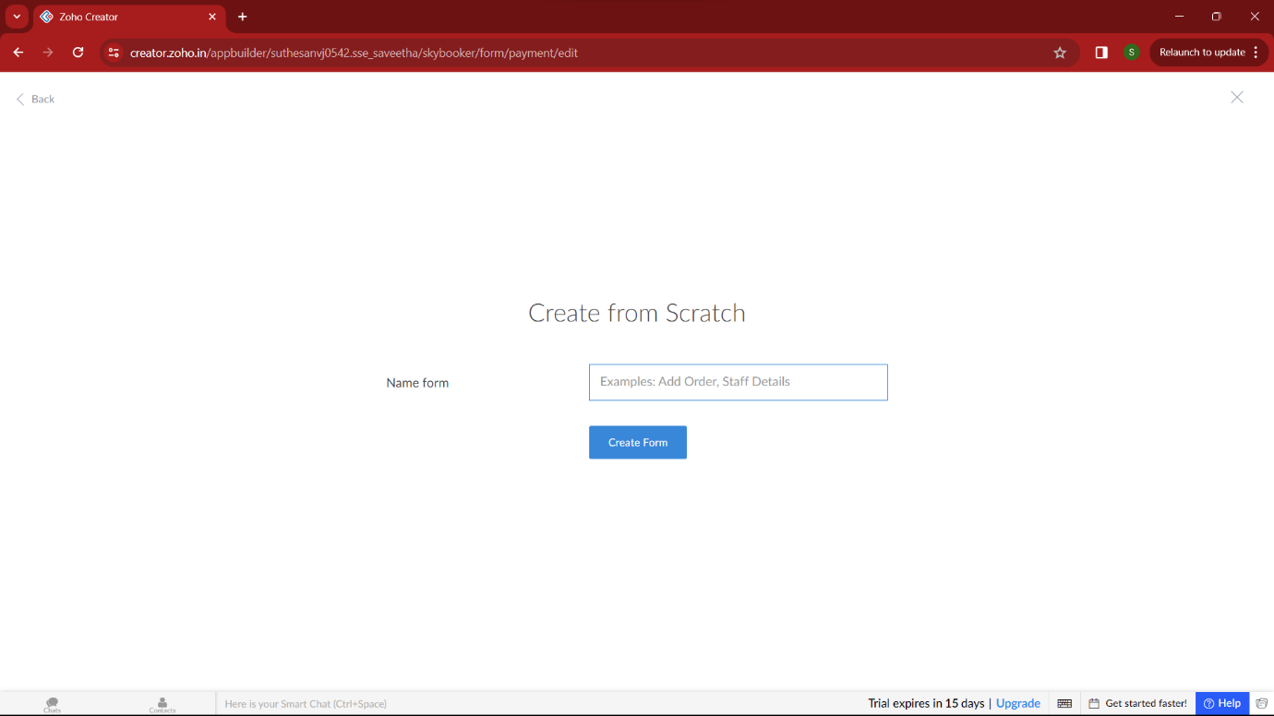

**STEP 5:**

by clicking “+” symbol shown in the picture given below, we can add number of forms in our application. Firstly I placed login form in my application with the essential credent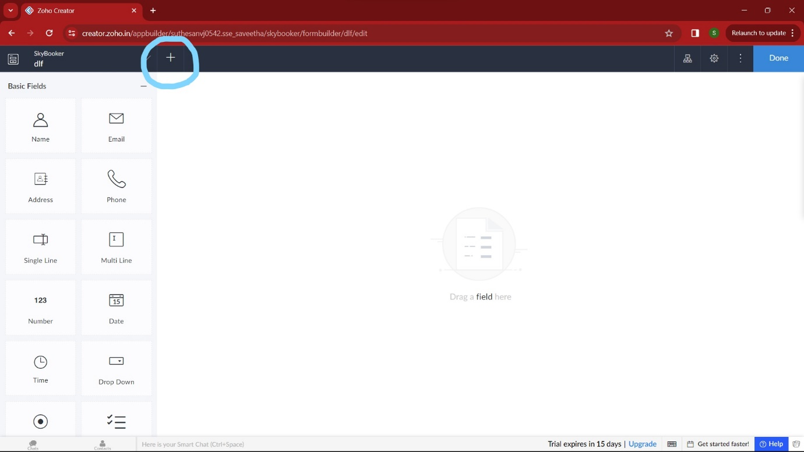

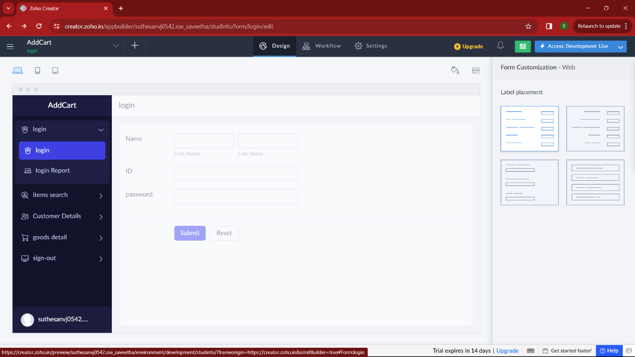

**STEP 6:**

Then I added another form namely login “item search”. It enables easy search of items in the supermarket to the user easily.

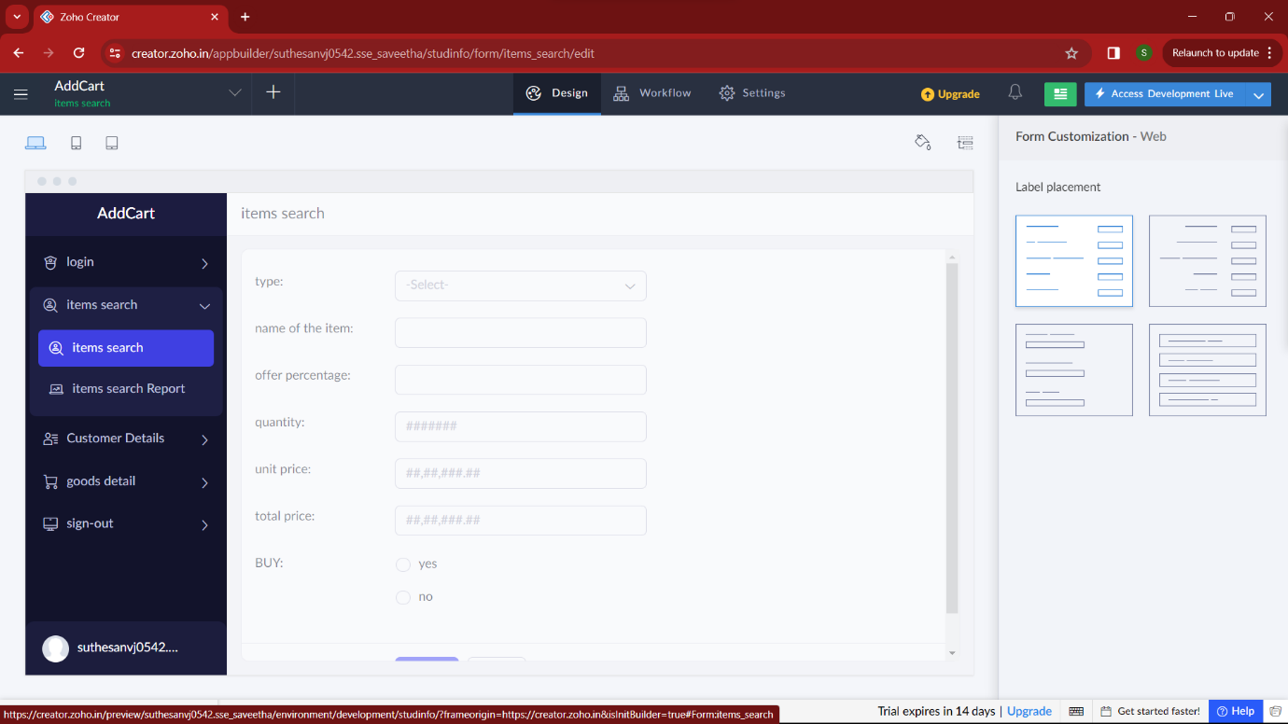

**STEP 7:**

Then I added another form namely “Customer details” which contains all the necessary details of the customer of the supermarket.

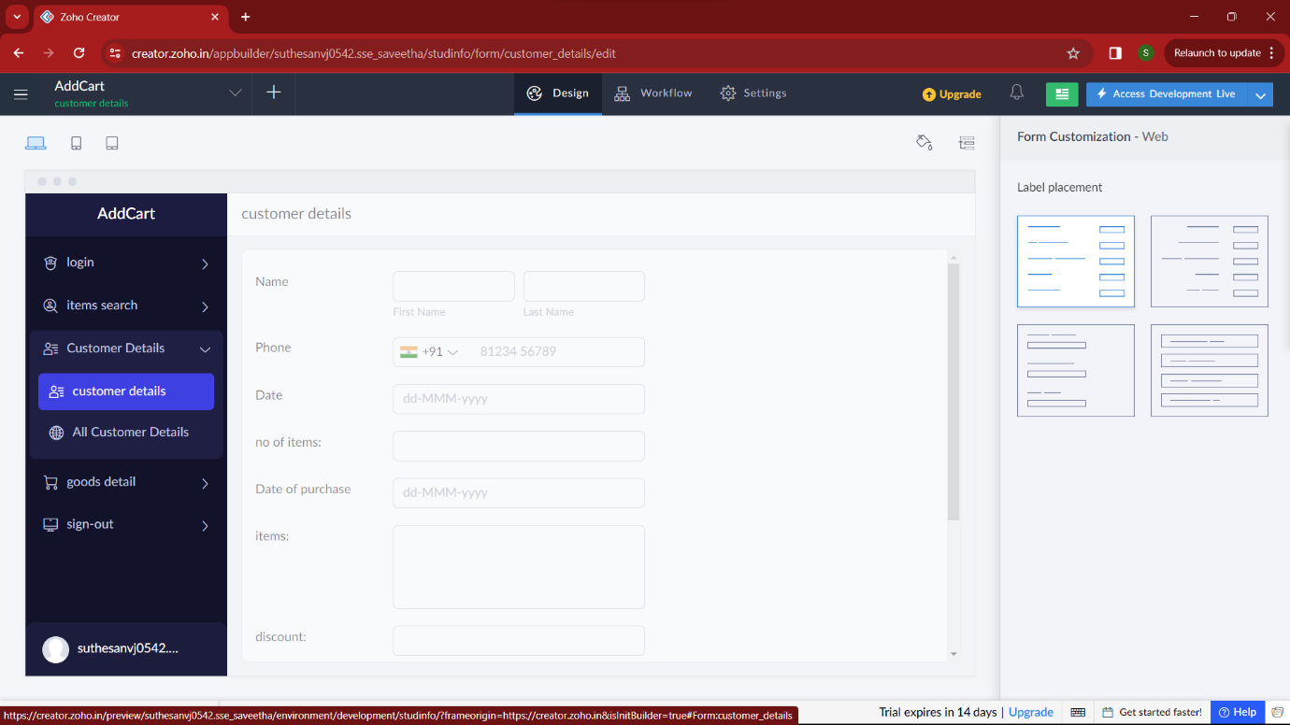

**STEP 8:**

Then in the next form I added “goods details” of the selected thing. Here user/admin can easily get the data of import of goods.

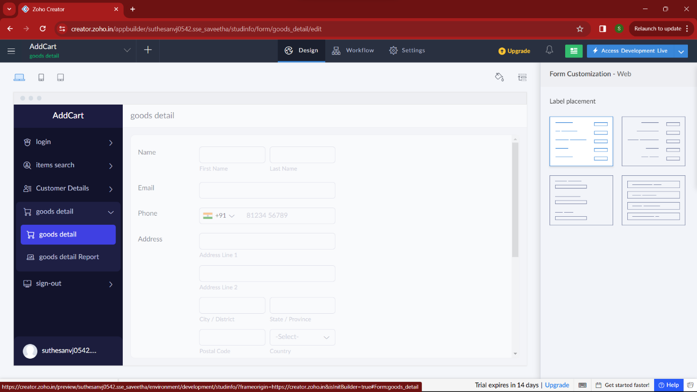

**STEP 9:**

In this form , the user /admin can signout with essential credentials.

